**NATIONAL INSTITUTE OF TECHNOLOGY SILCHAR**

**Cachar, Assam**

**B.Tech. IVth Sem**

**Subject Code:** CS204

**Subject Name:** Theory of Computation

**Submitted By:**

**Members of Group 15:**

1. Rahul Gautam Singh 1912082
2. Ashish Upadhyaya 1912132
3. Prottay Kumar Adhikary 1912157
4. Saurabh Sinha 1912159
5. Subhojit Ghimire 1912160
6. Let L = {ab, aa, baa}. Which of the following strings are in L*: abaabaaabaa, aaaabaaaa, baaaaabaaaab, baaaaabaa? Which strings are in L4?

* Strings in L* are: abaabaaabaa, aaaabaaaa and baaaaabaa

Explanation:

Let, S1 = ab, S2 = aa, S3 = baa

abaabaaabaa can be completed as S1S2S3S1S2, hence it is L*

aaaabaaaa can be completed as S2S2S3S2, hence it is L*

baaaaabaaaab cannot be completed as S3S2S1S2S2b, hence it is not L*

baaaaabaa can be compelted as S3S2S1S2, hence it is L*

Strings in L4 are: aaaabaaaa and baaaaabaa

Explanation:

L* term S1S2S3S1S2 uses 5-S terms, hence it is not L4

L* term S2S2S3S2 uses 4-S terms, hence it is L4

L* term S3S2S1S2 uses 4-S terms, hence it is L4

1. Let ∑ = {a, b} and L = {aa, bb}. Use set notation to describe $\overline{L}$.

* Set notation $\left\{λ, a, b, ab, ba\right\}∪\left\{w ∈{\left\{a, b\right\}}^{*} \right|\left|w\right| ≥3\}$ describes complement of L

Explanation:

L = {aa, ab} has both elements in even quantity, meaning, the strings generated by Language L = {aa, ab} will be of even length.

The complement of L will be universal set U – {aa, ab}, which is equal to the union of {λ, a, b, ab, ba} and strings of length greater than or equal to 3 {w Є {a, b}* | |w| ≥ 3}.

1. Find grammars for ∑ = {a, b} that generate the sets of
   1. All strings with exactly one a.
   2. All strings with at least one a
   3. All strings with no more than three a’s
   4. All strings with at least three a’s

In each case, give convincing arguments that the grammar you give does indeed generate the indicated language.

* For ∑ = {a, b},

1. S → XaX

X → bX|λ

1. S → XaX

X → aX|bX|λ

1. S → XaXaXaX  
   X → bX|λ
2. S → XaXaXaX

X → aX|bX|λ

1. Let ∑ = {a, b}. For each of the following languages, find a grammar that generates it.
   1. L1 = {anbm : n ≥ 0, m > n}
   2. L2 = {anb2n : n ≥ 0}
   3. L3 = {an+2bn : n ≥ 1}
   4. L4 = {anbn-3 : n ≥ 3}
   5. L1L2
   6. L1 ᴜ L2
   7. L13
   8. L1*

* Grammar to generate each of the given languages,

1. S1 → aS1b|S1b|b
2. S2 → aS2X1|λ

X1 → bb

1. S3 → aS3b|X2

X2 → aa

1. S4 → aS4b|X3

X3 → aaa

1. S5 → S1S2
2. S6 → S1
3. S7 → S1S1S1
4. S8 → S8S1|λ
5. Show that the grammars S → aSb|bSa|SS|a and S → aSb|bSa|a are not equivalent.

* For the grammar S → aSb|bSa|SS|a,

S → aSb → abSab →abSSab → abaaab

For the grammar S → aSb|bSa|a,

S → aSb → abSab

In the second case, S cannot be replaced by aa, as there are no more possibility for S → aa.

This shows that the given two grammars are not equivalent

1. For ∑ = {a, b}, construct dfa’s that accept the sets consisting of
   1. All strings with exactly one a
   2. All strings with at least one a
   3. All strings with no more than three a’s
   4. All strings with at least one a and exactly two b’s
   5. All the strings with exactly two a’s and more than two b’s

* DFA’s that accept the given sets

1. 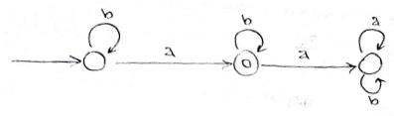
2. 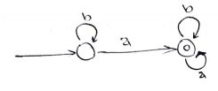
3. 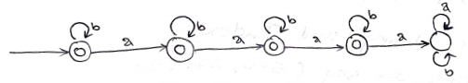
4. 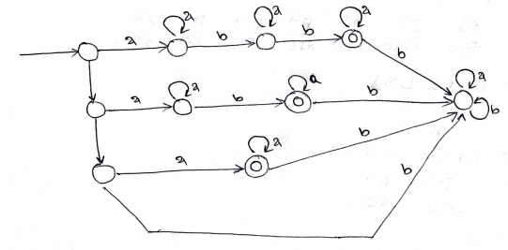
5. 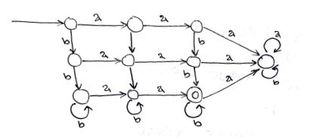
6. Consider the set of strings on {0, 1} defined by the requirements below. For each, construct an accepting DFA.
   1. Every 00 is followed immediately by a 1. For example, the strings 101, 0010, 0010011001 are in the language, but 0001 and 00100 are not.
   2. All strings containing 00 but not 000.
   3. The leftmost symbol differs from the rightmost one.
   4. Every substring of four symbols has at most two 0’s. For example, 0011110 and 011001 are in the language, but 10010 is not since one of its substrings 0010 contains three zeros.
   5. All strings of length five or more in which the fourth symbol from the right is different from the leftmost symbol.
   6. All strings in which the leftmost two symbols and the rightmost two symbols are identical.
   7. All strings of length four or greater in which the leftmost three symbols are the same, but different from the rightmost symbol.

* Constructing DFAs for the strings with the given requirements

1. 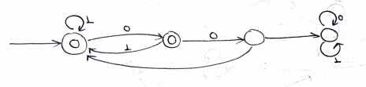
2. 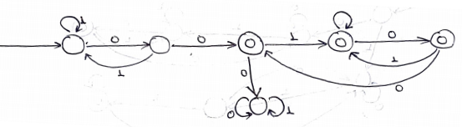
3. 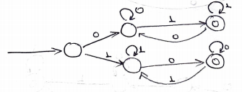
4. 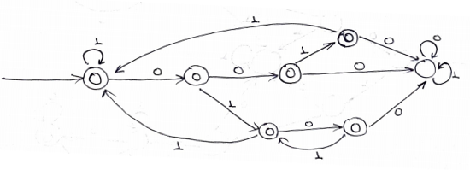
5. 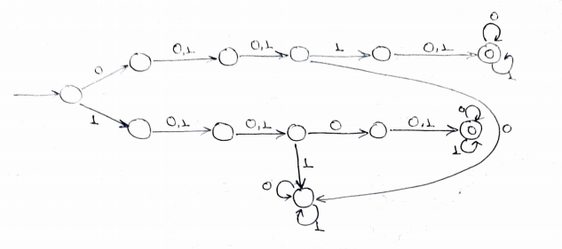
6. 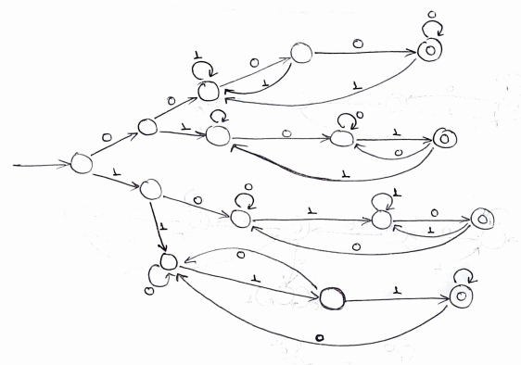
7. 